How to run ionic Angular project

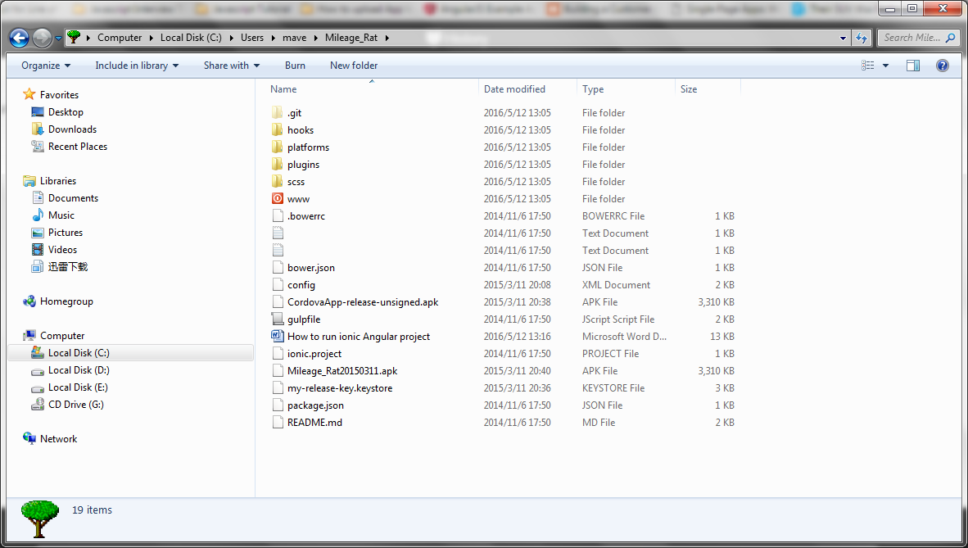

Must have a folder name WWW, then ionic can find this folder

Open git command line

$cd Mileage_Rat

$Mileage_Rat

$ionic serve

var express = require('express');

var router = express.Router();

var multer = require('multer');

var done = false;

var AWS = require('aws-sdk');

var dd = new AWS.DynamoDB();

var s3 = new AWS.S3();

var bucketName = 'eaton-resume-bucket';

AWS.config.update({region:'us-east-1'});

router.use(multer({

dest: './uploads/',

rename: function(fieldname, filename){

return filename;

},

onFileUploadStart: function (file, data, req, res) {

console.log(file.originalname + ' is starting ...')

var params = {

Bucket: bucketName,

Key: file.name,

Body: data

};

s3.putObject(params, function(perr, pres){

if (perr){

console.log("Error uploading data: ", perr);

} else {

console.log("Successfully uploaded data to Eaton Resume Bucket");

}

});

},

onFileUploadComplete: function(file) {

console.log(file.fieldname + ' uploaded to ' + file.path)

done = true;

putItem("test@email.com", "6/5/2015", "Recruiter", "101");

}

}));